Lecture 6, September 9, 2010 (Key Points)
6.1 Energy Balance and Evaporation
Strong linkage between the water cycle and the planetary climate can be illustrated by the estimates of the mean global surface energy budget. Over large areas and over sufficiently long periods (annual or longer), when effects of unsteadiness, melt and thaw, photosynthesis and burning, and lateral advection can be neglected, surface energy balance can be written as (Brutsaert, Ch.1)

(6.1)

Here is the specific flux of net incoming short-wave radiation. The unit of measurement is [W Kg⁻¹ m⁻²=J s⁻¹ Kg⁻¹m⁻²]. The major portion of the incoming radiation is absorbed near the surface of the Earth, and it is transformed into internal energy. The subsequent partition of this internal energy includes long-wave radiation back into the atmosphere, upward thermal conduction and convection as sensible heat H. E denoting the rate of evaporation in units of energy is one of the main processes driving the planetary climate system. is the latent heat of vaporization (Brutsaert, 2005, Ch. 3). E also connects the global energy balance with global water balance introduced in Lecture 2. Therefore, understanding evaporation is of fundamental importance to hydrology.
Brutsaert (Table 1.4) illustrates that the net energy is mainly disposed of as evaporation. Over the oceans, the latent heat flux is on average larger than 90 percent of the net radiation. But even over the land surfaces of the Earth, is on average still larger than half of . E over land also includes transpiration from the plants As a result of the relatively large latent heat of vaporization, evaporation of water involves the transfer and redistributiuon of large amounts of energy under nearly isothermal conditions. Because, even at saturation, air can

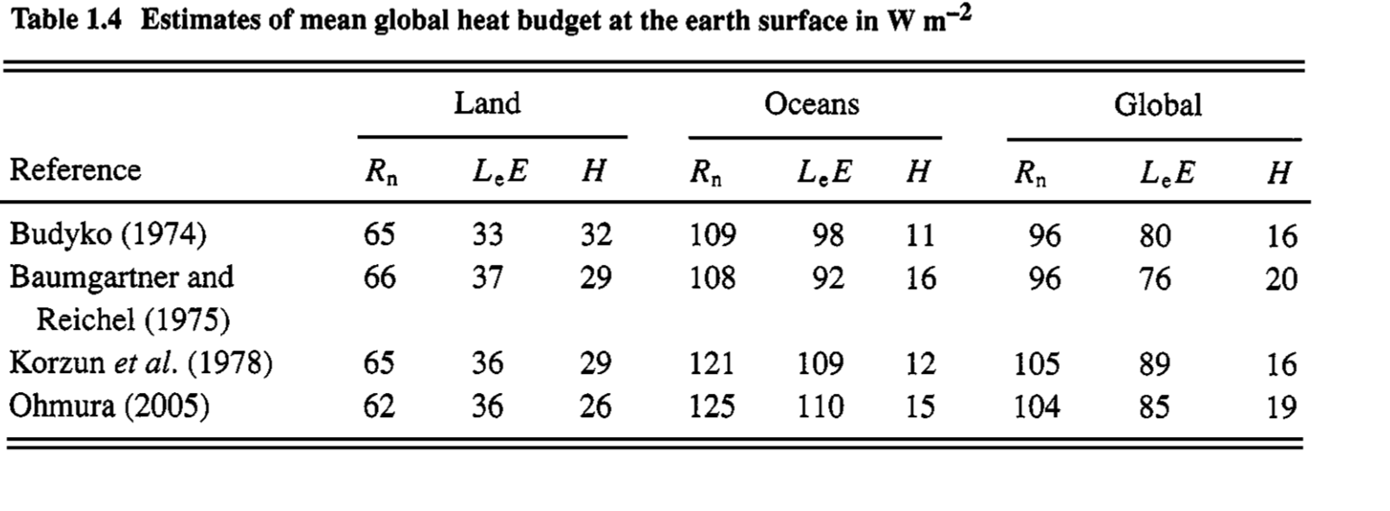
contain only relatively small amounts of water vapor, which can easily be condensed at higher levels, the air can readily be dried out; this release of energy through condensation and subsequent precipitation is the largest single heat
source driving the planetary climate system.
6.2 Estimating ET Across Spatial Scales in Annual Water Balance

To understand recent research related to the Turc’s equation that gave the best estimates of mean annual evapotranspiration in Poveda et al. (2007) (Lecture 5), we consider an important work on the topic that is based in the classic work of Budyko (1974).

(1) For large enough time scales, the dominant water source for the evaporation is precipitation P, and to a good approximation, the only relevant energy source is the net radiation . Budyko (1974) reasoned that

(6.2)

In principle, a negative mean sensible heat ﬂux or the transport of external river water to the region in question could lead to an E value that exceeds P or . Such situations, however, are presumably rare.

- Under assumptions in item (1), dimensional analysis leads to

(6.3)

Here, is called the “radiative index of dryness”. Budyko (1974) developed a semi-empirical functional form for the r.h.s in Eq. (6.3), which is well known in the literature ((Choudhury,1999, Eq. 1). The figure below gives a graphical representation of Budyko equation (Koster and Suarez, 1999).

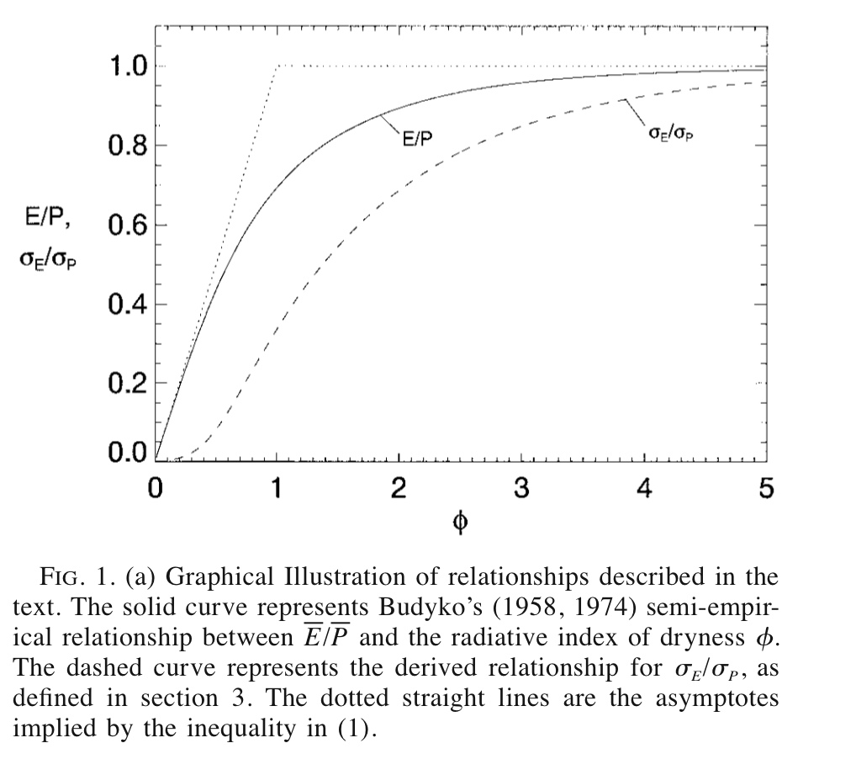

(3) Choudhury (1999) considered Budyko’s equation for ET to understand the effect of spatial variability on annual ET over a very wide range of spatial scales. He analyzed two extreme set of spatial scales, field scales ~1 km² where ET measurements were available, and large global river basins ~10⁶ km², where ET was calculated using a detailed physical model (cited and explained in his paper).

(4) Choudhury found that the following expression gives values of ET within 3% of the original expression that Budyko had considered.

(6.4)

(5) Budyko showed that is proportional to potential evapotranspiration (PET) (denoted as in Turc’s equation) (Budyko, 1974, Fig. 99, p.338). It is defined as evapotranspiration from a saturated land surface. An important point to note is that is measured globally. By contrast, estimation of PET especially at the spatial scales of a field and a river basin, is not a simple issue.

(6) The effects of spatial variability in precipitation and radiation on ET, as one moves up from field scales to medium and large river basin scales, is given in Section 2.3. Let denote the frequency functions of spatially variable and respectively. Let the r.h.s of Eq. (6.4) be denoted by, ( is suppressed for notational convenience as in Choudhury). Then the spatially averaged ET over a region is given by,

(6.5)

(7) Alternatively, if the spatially averaged values, are used in Eq. (6.4) the resulting expression is denoted as . Choudhury gives a nice analytical explanation to find a relationship between and .

(8) The key idea in item (7) is to expand the function in a Taylor series up to the second order term, and evaluate the integrals. It is given by Choudury (1999, Eq. (11)). It shows that is less than (It is known as the Jenson’s inequality in the probability literature).

(9) Choudhury hypothesized that α will be smaller for large river basins ~10⁶ km² than for field plots ~1 km², because variances of P and tend to increase with spatial scale due to spatial variability.

(10) Choudhury (1999) estimated at field scales and for large river basins, which supported his hypothesis in item (8). Further, he noted that if is used to estimate (same value as in the Turc’s equation), the errors can be expected to be les than 10% over a very wide range of spatial scales of river basins. For , eq. (6.4) becomes scale invariant with respect to spatial scales in the sense that the parameter α does not vary form one scale to the next. Scale invariance is a key concept that is being used in modern theories of nonlinear geophysics including hydrology. We will learn a lot about its applications to hydrology in this course.

(HW#3 would serve as a guide to understanding the papers in Lectures 5 and 6 in greater depth)

6.3 Prediction of annual flood statistics in a changing climate
We will briefly illustrate a road map to how annual flood quantiles may be predicted in a changing climate. First step is to use global climate models (GCM) that can predict E/P in a changing climate due to global warming. As an illustrative example, Figure-2 gives such a result from a 20-year GCM simulation (Koster and Suarez 1999).

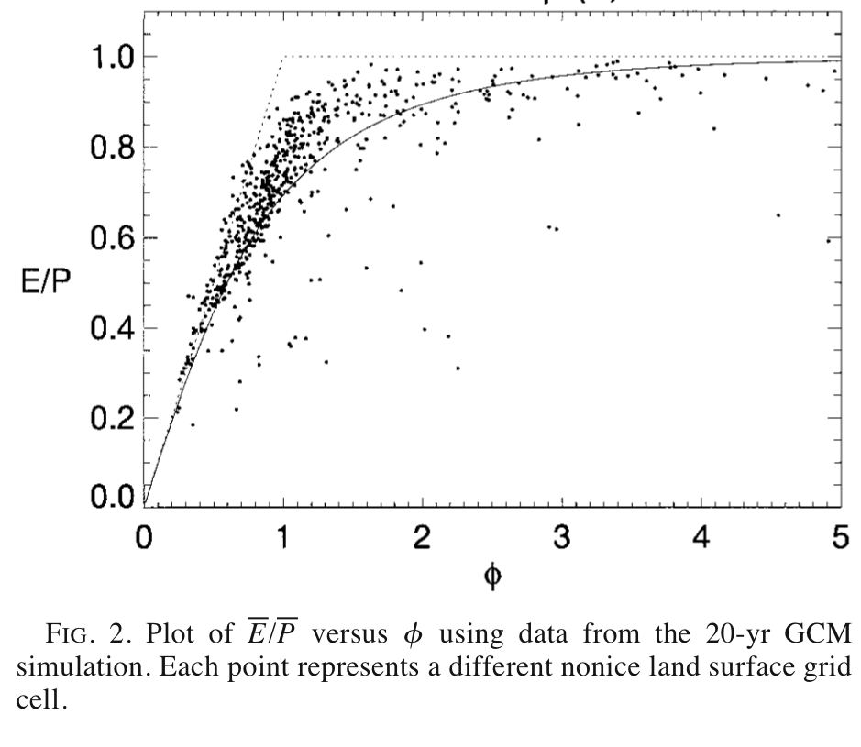
The water balance gives estimate of mean annual runoff,

(6.6)

Finally, a power law relationship between annual flood statistics and annual runoff Q can be used to predict flood statistics in a changing climate using results in Poveda et al. (2007) (see Lecture 5).
Koster and Suarez (1999) also derive an expression for the standard deviations governing interannual variability of P and E that is based in Eq. (6.3),

(6.7)

A plot of is given in Fig. 1. There are many outstanding challenges that remain to be solved before these ideas would be applicable in practice. Further discussion of this topic belongs to CVEN 6333.
References
M. Budyko, Climate and Life, Academic press, 1974.
B. Choudhury, J. Hydrology, 216, pp. 99-110, 1999.
R. D. Koster and M. Suarez, J. Climate, pp. 1911-1917, July 1999.

